Design Phase-II
Technology Stack (Architecture & Stack)

DATE | 31 January 2025
TEAM ID | LTVIP2025TMID30643
PROJECT NAME | Visualization tools for electric vehicle charge and range analysis
MAXIMUM MARKS | 4 marks

Technical Architecture:
The Deliverable shall include the architectural diagram as below and the information as per the table1 & table 2
Example: Order processing during pandemics for offline mode
Reference: https://developer.ibm.com/patterns/ai-powered-backend-system-for-order-processing-during-pandemics/

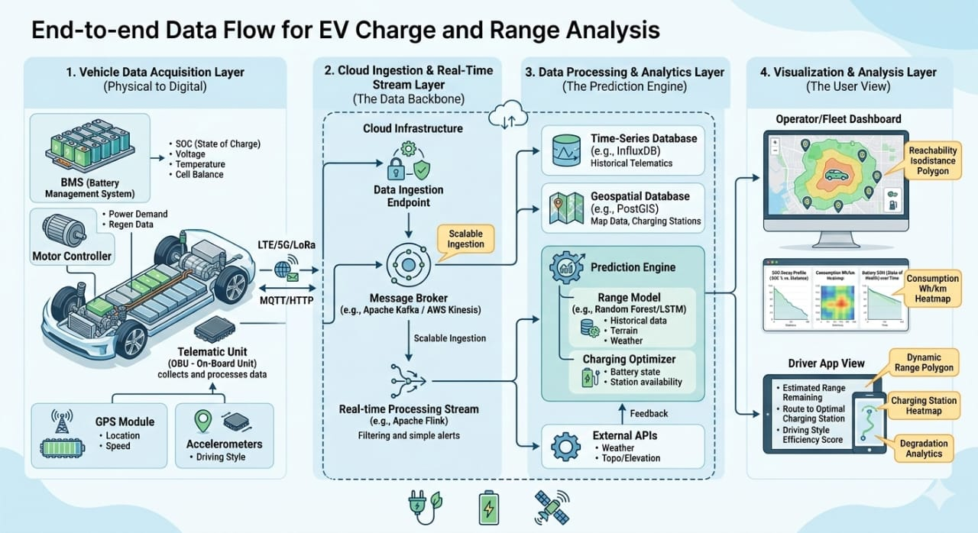

S.No | Components | Description | Technology
1 | User Interface | Dashboard for real-time range visualization, battery percentage (SOC), and charging station map. | HTML, CSS, React.js, Map box GL JS
2 | Application Logic-1 | Range Estimation Engine: Calculates distance based on battery health, road terrain, and driving style. | Python (Fast API), Scikit-learn
3 | Application Logic-2 | Telematics Handler: Manages real-time data flow from the vehicle’s Battery Management System (BMS). | MQTT, Node.js
4 | Application Logic-3 | Telematics Handler: Manages real-time data flow from the vehicle’s Battery Management System (BMS).  MQTT, Node.js | Java / Python
5 | Database | Stores user profiles, vehicle metadata, and fixed charging station locations. | MySQL / PostgreSQL
6 | Cloud Database | High-speed storage for continuous time-series data like battery voltage and temperature.  Influx DB / MongoDB | Influx DB / MongoDB
7 | File Storage | Storage for trip logs, historical range reports, and map data.  AWS S3 / IBM Cloud Object Storage | AWS S3 / IBM Cloud Object Storage
8 | External API-1 | Accesses real-time traffic and charging station status. | Open Weather API, Google Elevation API
9 | External API-2 | Accesses real-time traffic and charging station status. | HERE Maps API, Open Charge Map API
10 | Machine Learning Model | Predictive model used for analyzing long-term battery degradation and consumption patterns.  Random Forest / LSTM Models | Random Forest / LSTM Models
11 | Infrastructure | Cloud-based deployment for scaling services and handling vehicle data streams. | Kubernetes, AWS / Azure

